Probabilistic Machine Learning cw2 – Probabilistic Ranking



From the lecture slides ‘L7-gibbs in TrueSkill’, the mean of the conditional skill distribution is denoted as an array of skills of different players $i$, i.e. $\underline{\tilde{μ}}={\left[\tilde{μ_{i}},…,\tilde{μ_{M}}\right]}^{T}$, where M is the number of players (107) played in these N = 1801 tennis matches. Each ith element in the mean array can be calculated by the following equation.

$$\tilde{μ_{i}}=\sum_{g=1}^{G}{t_{g}\left(δ\left(i-I_{g}\right)-δ\left(i-J_{g}\right)\right)}$$

The mean of each player’s conditional skill is equal to the sum of the performance difference of that game g. If the player wins, the performance different will be positive; reversely, it will be set to negative. As the result, for each player, the list of indices of matches which the player had played is created, and it is split into lists of indices responsible to win and lose. So that the lists of performance difference for win and lose can be created. Then the mean of the player can be found.

The combined precision is given by the following equation.

$${\left[{\tilde{Σ}}^{-1}\right]}_{ii}=\sum_{g=1}^{G}{\left(δ\left(i-I_{g}\right)+δ\left(i-J_{g}\right)\right)}$$

$${\left[{\tilde{Σ}}^{-1}\right]}_{ij}=-\sum_{g=1}^{G}{\left(δ\left(i-I_{g}\right)δ\left(j-J_{g}\right)+δ\left(i-J_{g}\right)δ\left(j-I_{g}\right)\right)}$$

The diagonal element of the matrix represents the number of matches that a player has player. And the non-diagonal represents the number of matches a player (i) has played against the player (j).

 

To find skills according to the prior mean, Gibbs sampling is applied. For each iteration, a random sample from the mean array is replaced by another sample from the same array to form another mean array, then the next skill array will take the mean of the mean arrays of the previous iterations.

To show how skills converge throughout iterations, the auto-covariance coefficient of each player in each iteration is computed. It was done by inputting mean skills arrays of all iteration into the ‘xcov’ function, and summing up every 1100 columns. The resulting matrix (107x1100) is the auto-covariance coefficients of each player in each iteration.

 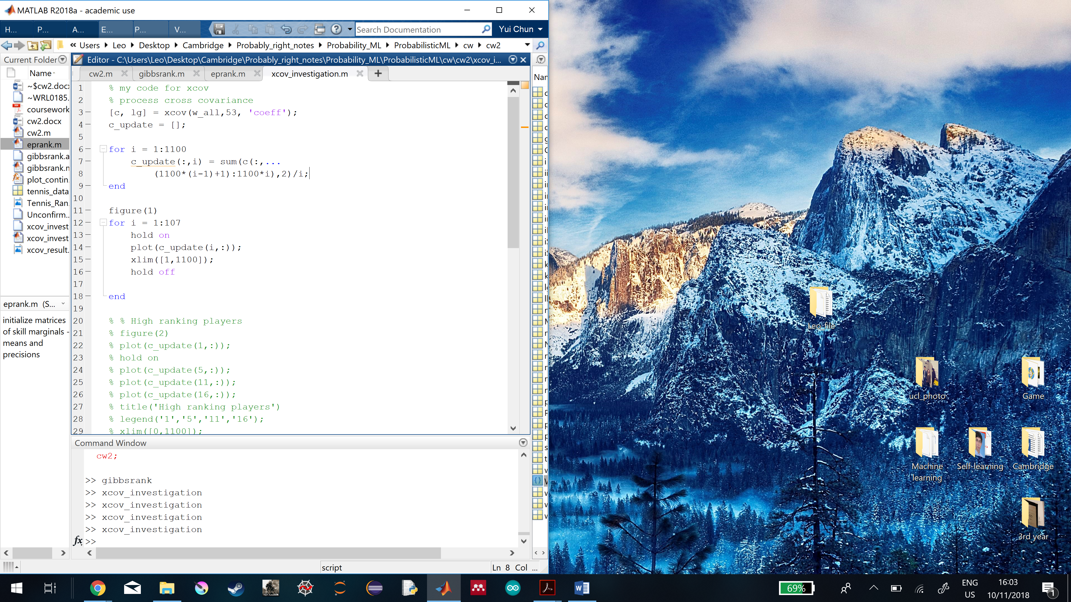

The auto-covariance coefficient describes how the skill of each player in a given iteration contradicts with the previous iteration.

The Gibbs sampler does not look moving the whole posterior distribution around. The burn-in time begins at 200th iteration, and the mixing time is from 1st to 200th iterations.



For both algorithms, convergence means a given array becomes stabilised over iteration. In terms of Gibbs sampler, the value of auto-covariance coefficient becomes very close to zero, and the difference between the coefficient and the zero value cannot be shortened anymore.

In the message passing algorithm, since the mean skill value converges very quickly, convergence is reached (defined more strictly) when the mean skill value can no longer change. It requires 200 iterations to converge.

The Gibbs sampler converges in terms of auto-covariance coefficient, the message passing converges by the difference between the current and previous iterative mean skill. It only requires 70 iterations to converge.

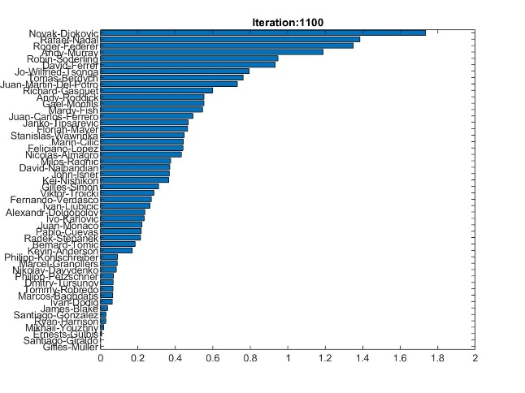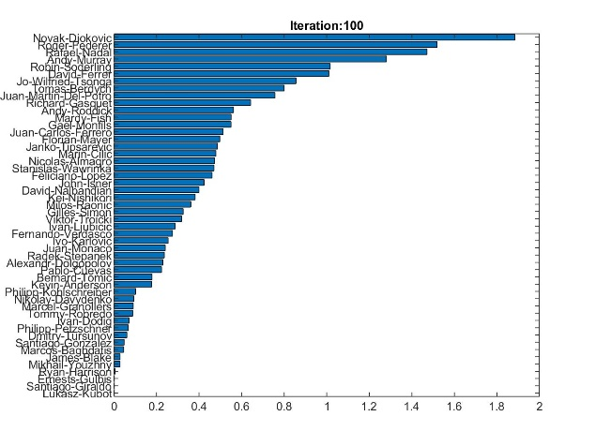

No, different answers are found in these two algorithms. For the skill means, the message passing gives a greater value for each player in general. Although the rankings of the high rank players agree, the lower rank players begins to differ.



Probabilities that the skill of one player is higher than the other $∼\text{N}\left(0,1\right)$

|  |  |  |  |  |
| --- | --- | --- | --- | --- |
|  | Djokovic, Novak | Nadal, Rafael | Federer, Roger | Murray, Andy |
| Djokovic, Novak |  |  |  |  |
| Nadal, Rafael |  |  |  |  |
| Federer, Roger |  |  |  |  |
| Murray, Andy |  |  |  |  |

Probability of one player winning a match between the two

$$t=w_{1}-w_{2}+n$$

, where $n∼N\left(0,1\right)$. So,

$$t∼N\left(w_{1}-w_{2,}1\right)$$

|  |  |  |  |  |
| --- | --- | --- | --- | --- |
|  |  |  |  |  |
|  |  |  |  |  |
|  |  |  |  |  |
|  |  |  |  |  |
|  |  |  |  |  |